input.doc Name_________________________

During an experiment the temperature of a substance is measured each minute for a ten minute period.
Temperature in degrees Celsius is a function of time in minutes: c=f(m).

1) Explain the meaning of each of the following in terms of time and temperature. Include units.

a) f’(3) = 2

b) f’(5) = -3

c) f’(8) = 0

2) What would it indicate about the sign (+, -, or 0) of f’(x) and f’’(x) if each of the following were true for the duration of the experiment?

a) The temperature is increasing by less than it did the previous minute.
time
temp

f’(x) = _____ f’’(x) = _____ sketch:

b) The temperature is increasing by more than it did the previous minute.
time
temp

f’(x) = _____ f’’(x) = _____ sketch:

c) The temperature is decreasing by less than it did the previous minute.
time
temp

f’(x) = _____ f’’(x) = _____ sketch:

d) The temperature is decreasing by more than it did the previous minute.
time
temp

f’(x) = _____ f’’(x) = _____ sketch:

e) The temperature is increasing by the same amount as it did the previous minute.
time
temp

f’(x) = _____ f’’(x) = _____ sketch:

3) Your grade (as a %) on a test is a function of the amount of time in hours spent studying g=f(t).
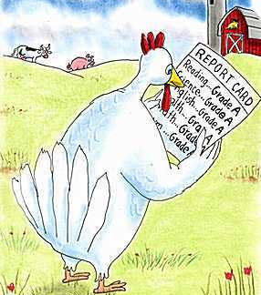
time
grade

What is the meaning of f(2) = 90?

What is the sign of f’?______ What does it suggest about studying?

What is the meaning of f’(2) = 5?

What is the sign of f’’?______ What does it suggest about studying?

What is the meaning of f’’(2) = -3?

